H.C. Bennett Company
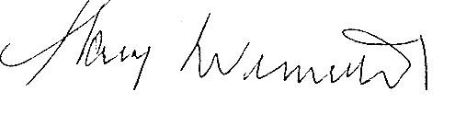
Training for International Trade

E-Mail: dab@hcbennett.com www.hcbennett.com

Dave’s Questions on Segment 1 Reading

- Find the following citings …

  - Part 141
    - Resident agent for nonresident corporation
    - Contents of invoices
    - Liability for duties on reimportation
    - Partnership Power of Attorney requirements
    - Completion of the CF 7501 (Entry Summary)
    - POA (Power of Attorney) for noncommercial shipment
    - Quantity of merchandise for an entry
    - Amount of duties to be deposited

  - Part 113
    - Basic importation and entry bond conditions
    - Amount of bond
    - Consequences of default on bond
    - Cash deposits in lieu of sureties

  - Part 142
    - When an entry summary must be filed at the time of entry
    - Entry bond requirements
    - Amount of immediate demand for failure to file documentation timely
    - Merchandise eligible for Special Permit for Immediate Delivery
    - Failure to file entry summary timely

- You have one invoice, one bill of lading. How many entries can be made?

- What form do you use to apply for the CB License and what is the deadline to apply?

- Explain rule 3(c) of the GRI and give an example.

- What is the main area of the type of exam questions that you think you should concentrate on and why?

- In your own words (2 sentences max), how would you answer an importer’s inquiry of “what is the purpose of the Customs bond?”

- Name 4 Trade Acts and give the abbreviation that relates to that act in the Tariff.

- Explain how an importer can defer the payment of duties.

- On your CCM on Disk, there is a section on Clearance Tutoring (nuts & bolts of the CB process). Pick a clearance tutoring examination question that has relevance to this week’s reading.

- If you import a camera case with a camera, how is the case classified and what GRI is the basis for this?

